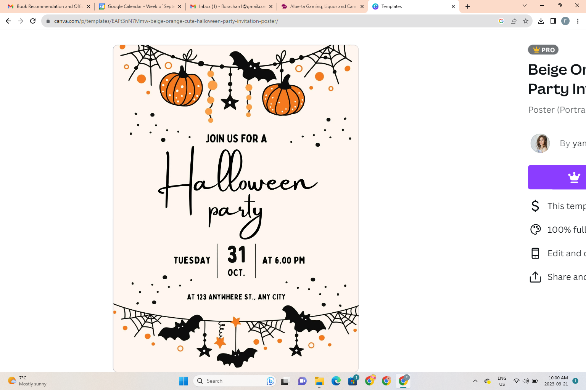

Halloween Dance & Pizza Party
Wear your costumes!
…but please leave the masks and weapons at home
Thursday, October 24, 2024
6 pm to 8 pm @ Harold Panabaker Junior High
Tickets $2 per person
PLEASE PRE-ORDER PIZZA and tickets at
hpschoolcouncil.square.site
OR RETURN FORM BELOW
Drinks and snacks will be available for purchase by cash at the dance.
Youth must be accompanied by an adult (1 adult per 4 youth).

Parent volunteers needed! Please email hpschoolcouncil@gmail.com

PIZZA ORDER FORM
Please return this portion to your homeroom teacher with payment in a sealed envelope by Friday, October 18, 2024.

Student Name ______________________________________ Grade-Homeroom ________________________
Dance Tickets # _______________ X $2 = $_______________
Pizza Slices # _______________ X $2.50 = $_______________ (please note quantity and choices below)
Cheese _________ Pepperoni _________ Hawaiian _________ Gluten-Free Cheese __________
Total Enclosed $________________________________
Cash ☐ (please send exact amount as change will not be sent home) E-transfer ☐ (send to hpschoolcouncil@gmail.com)

No tickets will be sent home. There will be a list of students who have pre-paid by the front doors where tickets and pizza will be handed out.

